**Date Submitted: 12/3/18**

Youtube Link: <https://www.youtube.com/watch?v=rVHt-YB6ibc&feature=youtu.be>

**Task 01: Update CC1350 Launchpad firmware**

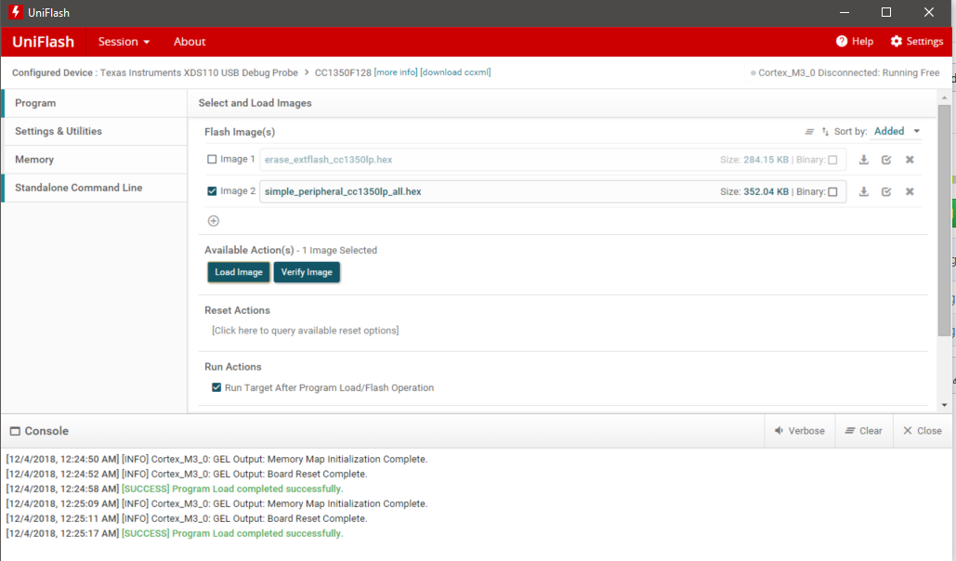

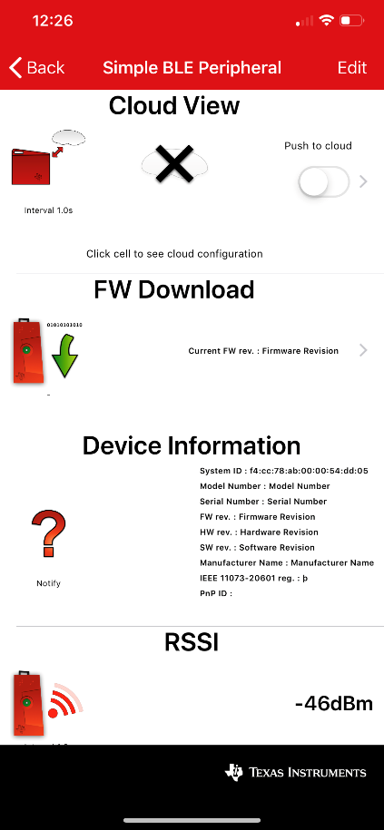 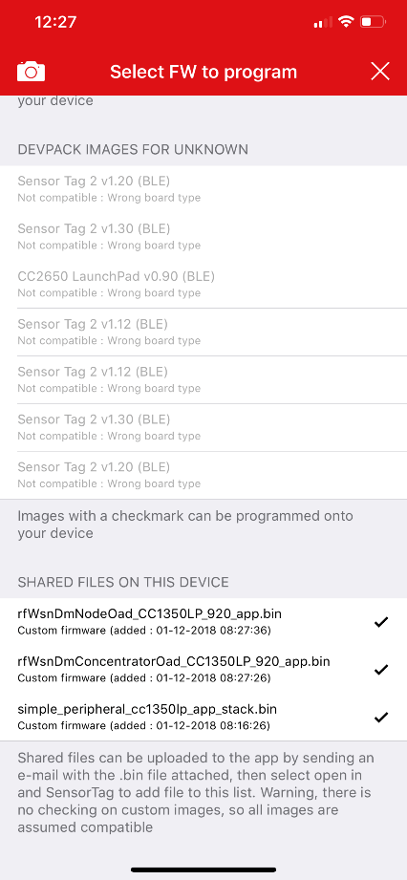 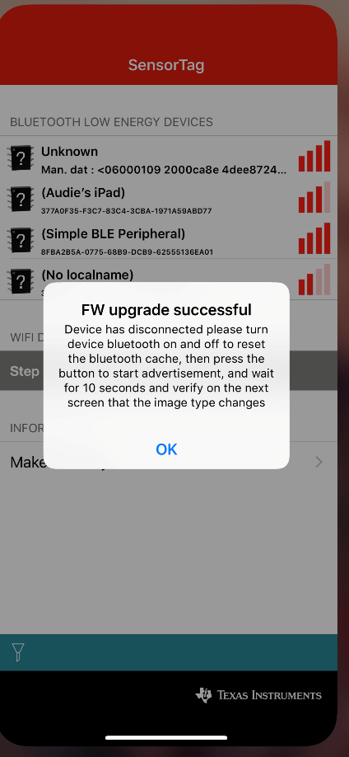

**------------------------------------------------------------------------------------**

**Task 02: OAD download sub-1Ghz firmware images**

concentrator:

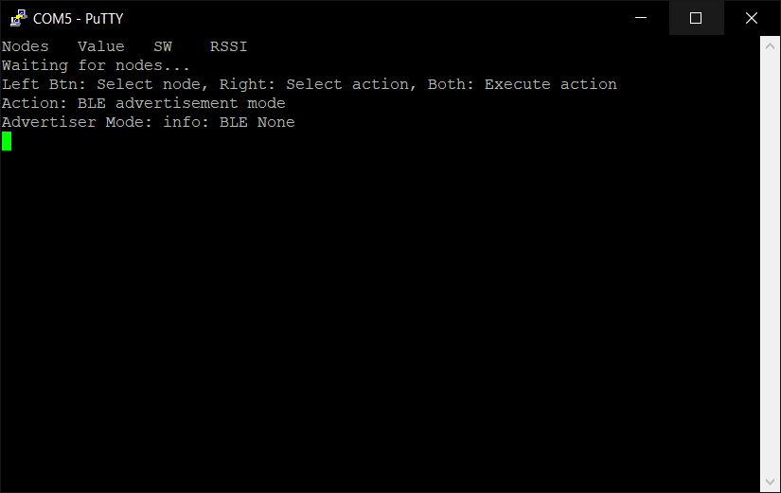

Node:

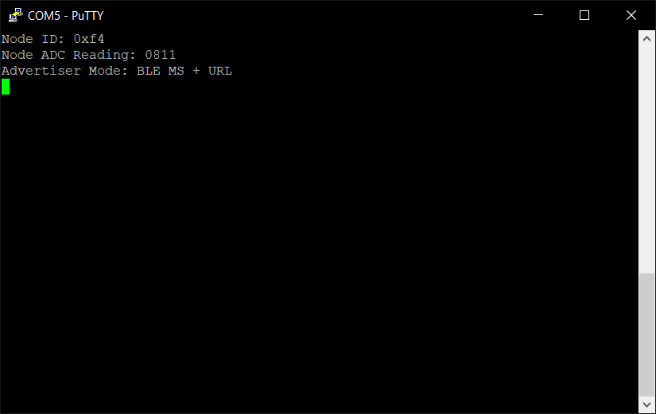

**------------------------------------------------------------------------------------**

**Task 03: Running the sub-1Ghz firmware**

**Concentrator**

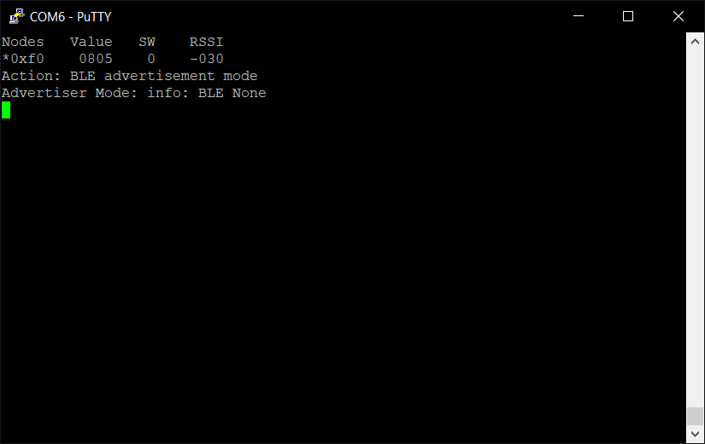

**Node:**



